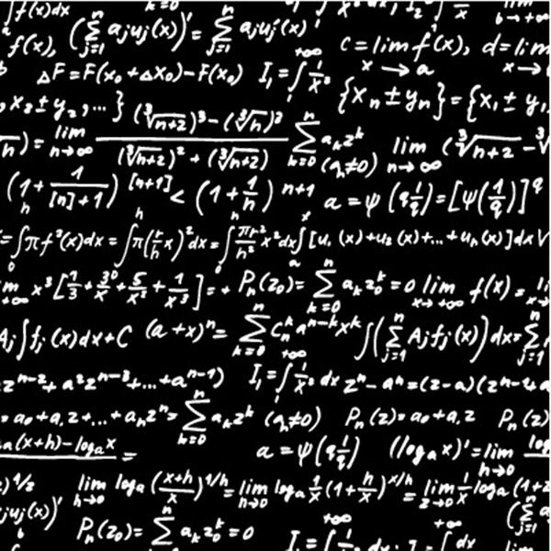**Software release 29**

There are two parts to a VTL-2 interpreter – the right expression and the left expression. The right expression is more complicated, but the left expression does more.

The right expression is pretty much done and dusted, I have written the code and thrown lots of random tests at like

“:48)/((( : 154)+3983+(( 56268/Z-1488 + C ) *8 )) -A-6198)/ 3538+572 )-116”

and it seems fine.

Incidentally the : is VTL-2’s array syntax ; :48) is the 48th array element beyond the end of program marker (in the ‘&’ variable) – because it is two bytes this is actually offset 96.